### Step 1: Create Notepad list

1. **Open File Explorer** and go to the folder where files are stored.
2. **Copy the file names into notepad by following below steps:**
   * Hold Shift and Right-click inside the folder (not on any file), then choose **"Open PowerShell window here"** (or Command Prompt).

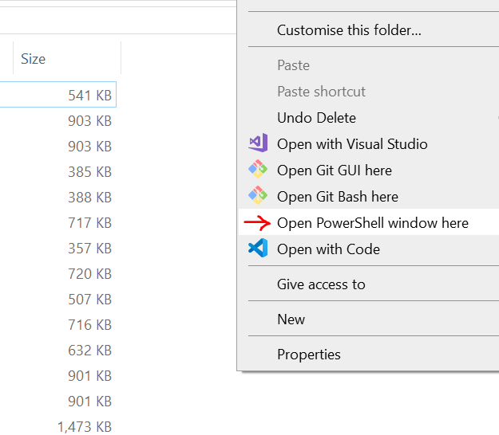

* + In the terminal window, type the following command to list the files in the folder.

dir -Name > filelist.txt



This creates a text file (filelist.txt) containing the names of the files in your folder.



### Step 2: Import filelist.txt into Excel:

* Open filelist.txt, select all (Ctrl+A), and copy the contents (Ctrl+C).
* Open new **Excel file** and paste the file names into **Column A** starting from A1.

Note: In notepad filelist will also be included, remove that from excel.

### Step 3: Create the Rename Formula in Excel:

Create an Excel file. Let's assume you have the file paths in **Column A** starting from A1. In **Column B**, write the new names you want for each file (without the file extension). In **Column C**, you'll create a formula to generate the batch rename command.

• **In Column B**, write the new names you want:

• **In Column C**, create the rename commands:

* In **C1**, enter the following formula:

="ren "&""""&A1&""""&" "&B1&".mp4"

{instead of mp4, write the file extension}

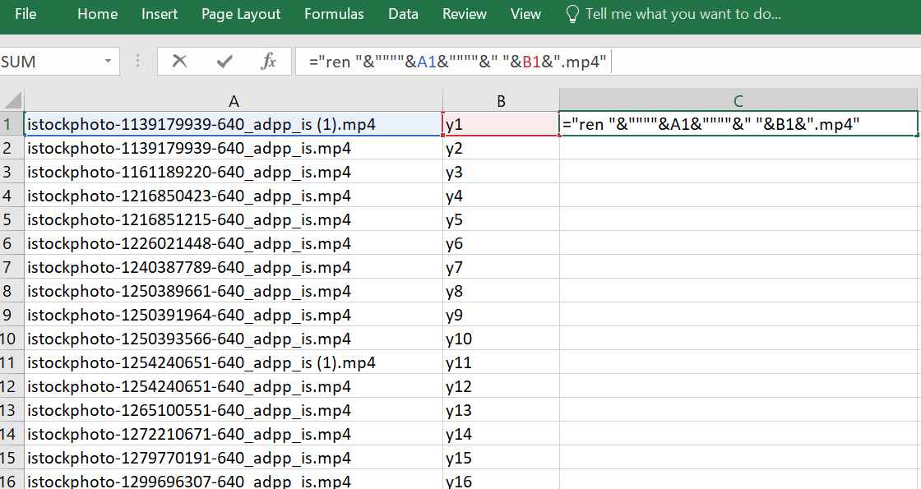

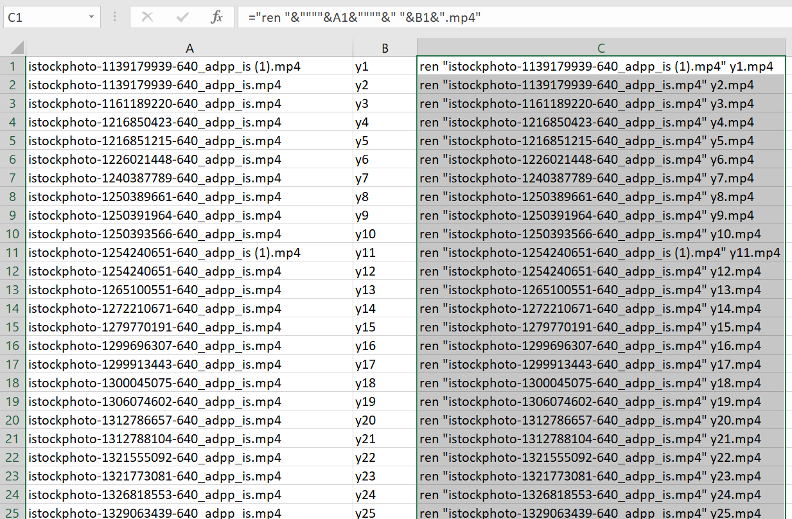

### Step 4: Export the Rename Commands to a Batch File

1. After generating the renaming commands in Column C, copy the entire **Column C**.
2. Open **Notepad** and paste the copied content.
3. Save the file as **rename_files.bat** (be sure to select "All Files" as the file type and add .bat to the filename).

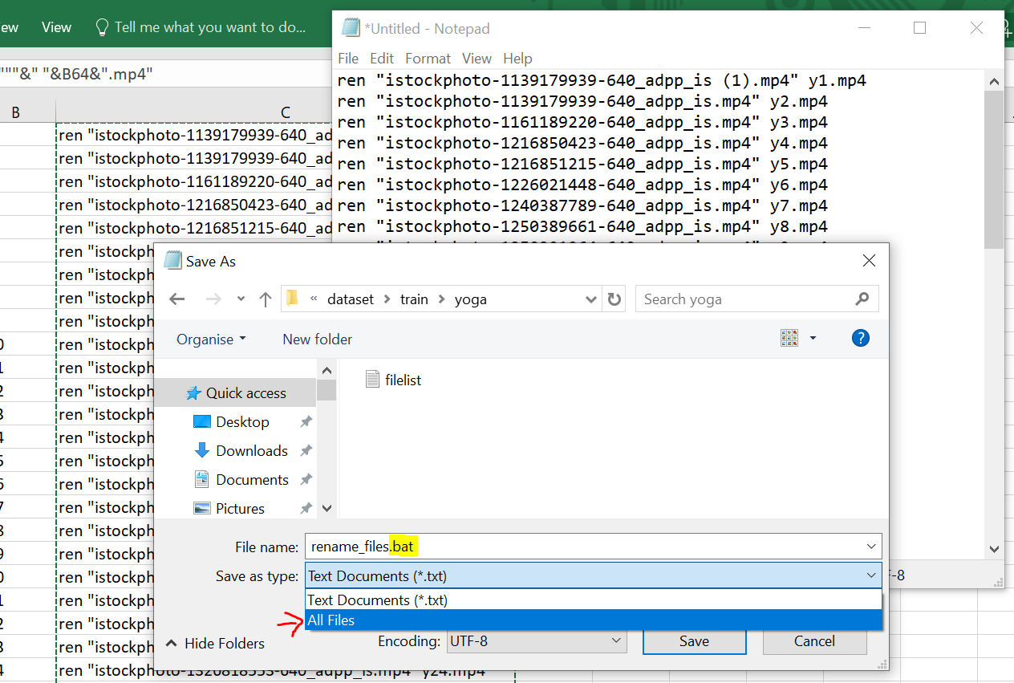

### Step 5: Run the Batch File

1. Move the rename_files.bat file into the folder where your files are located.

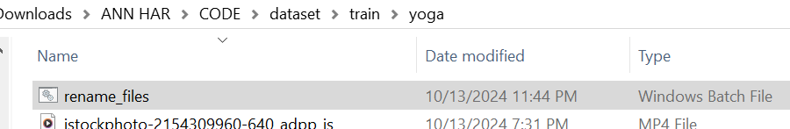

1. **Double-click** the rename_files.bat file to run it. This will rename your files all at once!

